AN ANALYSIS OF HYBRID ENERGY SYSTEMS OF
RENEWABLES & GAS.

Environmentalists for Nuclear Energy
June, 2012
(EfN:
Quotable remarks in red. Trying to be measured and avoid rant or sarcastic approaches throughout, though some criticisms must be made plainly.
The summary may be used as the short view of this article on our website.
This is one of several parts on Renewables, Nuclear+Fusion, and Economics.
Final set will include a 1500 word Article, covering all the key points for publication in the media.)
Summary
The UK Draft Energy Bill of 2012 has introduced a range of reforms to the way the UK energy market works, with the goal of raising confidence among long term investors in new energy systems. Here we present a new analysis of the role of renewables and how they should be managed and financed. Erratic renewables like Wind and Solar energy need to partner with rapid reaction gas fired power stations to level the output from this hybrid system. The Wind-Gas Hybrid system can never reduce its total emissions below 50% at any scale, which limits wind energy deployment to less than 20% by 2050. Any hope of energy independence and control of fuel costs is lost. The urgency to build a large system now is misplaced. Germany, Denmark and Scotland clearly show the impact of these hybrids on electricity prices. Scotland claims that they will generate 100% of their own electricity from renewables, mainly wind, by 2020. This is cannot be true as English gas power is needed to level the output on the grid. The determination of these states to drop nuclear energy has forced them to increase their coal fired electricity to meet their needs and keep the overall price within bounds, ensuring that emissions will rise.

Introduction
The Draft Energy Bill of 2012 has introduced a range of possible reforms to the way the UK energy market works, with the goal of raising confidence among long term investors in new energy systems. The new systems are supposed to be on the path to an 80% reduction in greenhouse gas emissions by 2050. The principal system planned for 2020 is a very expensive set of onshore and offshore wind farms, which will generate some emissions free electricity. Solar panels also do this, but not very well in English weather, and at the highest cost of any electricity system. How well does the Energy Department, DECC, understand these renewables? We will show that they are really part of a Hybrid system, partnered with natural gas. Examples of their performance and their impact on costs and energy policy across the EU will show what these developments will impose on the UK. Regulations and financial arrangements appropriate to these Hybrids is a subject for another report.
The Erratic Renewables
Solar output is at its highest in daylight in summer when it is not required for domestic purposes. It delivers less than 10% of its peak in winter when it would be most useful and none at all at night. The average performance is about 10% of its rated power. Solar power is poorly matched to users’ needs. The real cost of Solar electricity has been around 45p/kWh and is fully subsidized in Britain through Feed In Tariffs (FITs) to the owners.
Wind energy is up to 30% greater than its average in winter and down to 30% less in the summer. In all seasons, wind energy behaves erratically and cannot be matched alone to power loads on the National Grid. It is necessary that a second, reliable energy system, using natural gas, be run to level the output. We feel that the term ‘leveling’ is more accurate than ‘backup’, which implies some sort of temporary or occasional intervention. The two are so tightly coupled that they should be treated for technical and financial purposes as a single Hybrid Wind-Gas system.
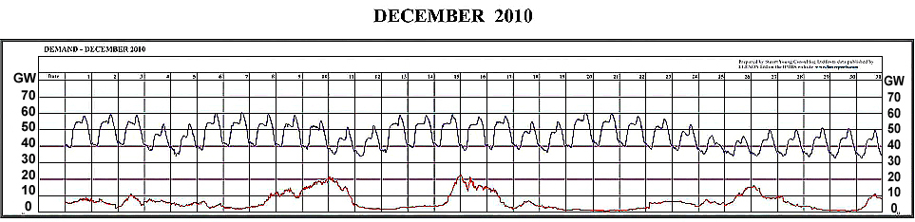
Here is a model of what happens in winter periods when a stationary mass of cold air can sit across the whole UK for many days (Stewart Consulting).
Figure 1. This shows the daily UK demand variation in December 2010, averaging some 50GW. The lower curve represents a group of existing wind farms around the UK, with rated output scaled up to a 30GW peak as planned. Output collapsed below a few percent of peak for some 12 days. Gas leveling for this failure is essential. The peak was never reached, so leveling is needed for only about 80% of the peak rating. The annual output of the Wind system is about 10GW or 1/3 of the rated power.
Regrettably, the open cycle gas turbines which can respond most rapidly to the multi-GW changes are less efficient than those used for base load power. Some 2/3 of the Hybrid gas fleet will be warming or cooling as wind power cycles up and down, leading to a further efficiency reduction. Future gas supplies will include more Liquified Natural Gas (LNG) which already use about 25% of its energy for refrigeration and transportation. Such external losses should be included in the overall Carbon emissions bill for this leveling service. Plainly, leveling operators must charge more than operators of base load supplies and regulations must reflect this.
The net result is that the this Hybrid system, producing a continuous 80% of the peak wind rating in winter, ~24GW , and 34%, or 11.2GW, in summer, will have the same emissions as an efficient gas system of 11GW and an average 10GW of wind. The Hybrid saves only 45% of emissions compared to a 20GW base load gas system.
Like the solar power, the wind energy can reach close to its rated peak of 30GW, or in summer to around 20GW. This could exceed the summer minimum demand and, in the German model, everything else would have to be turned off. A system of twice the size could exceed the output at the winter maximum. Common sense clearly demands a limit to the total wind energy allowed on the National Grid.
The Wind-Gas Hybrid system can never reduce total emissions below 50% at any scale. It is an expensive half measure. Any hope of energy independence and control of fuel costs is lost. This is apparent from examples across the EU.
GERMANY
Germany is the model and principle driver of the use of renewables. It is now providing clear evidence of what to expect if the UK continues on this path.
Germany invested hugely in solar panels and, having pledged the money in large subsidies, had to insist that its summer output take priority over everything else. German electricity is the second most expensive in Europe and so gas prices have been legislated down to the point where many gas stations are closing. This is an overshoot in provision by the political agenda and arbitrary interference in the gas sector which still has to maintain the provision as the sun sets. Solar should not be considered as a significant power source in UK till its costs at least match that of wind.
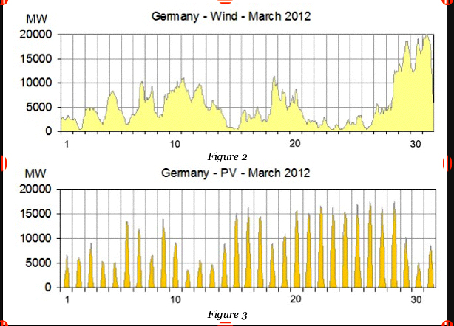
New data from Germany shows the extreme effects of very large usage of wind and solar power in the sunny month of March 2012.
Figure 2. German Wind and Solar power, each peaking at 15-20GW. The solar power does not cover the evening maximum demands. The wind power is below 10% of its peak for 5 days. Leveling power of 30GW peak is needed to provide stable electricity on the grid.
The solar power is largely generated in the south and the wind in the north and so huge and abnormal power transfers had to be made on the grid. This brought the grid close to collapse. The assigned leveling resources were used up and the operators had to intervene and curtail other renewables. Gas supplies were low in February, exposing weaknesses in the gas grid, so the situation could have been worse. A grid collapse of more than a day would be a national disaster as water, sewage, transport, lighting and heating all stopped. All of this is entirely predictable but systems based in ideology have to come to the brink of disaster before problems are recognised.
It seems likely that Germany will now build new coal stations to replace some of the nuclear being closed down. The goal of reducing emissions will be deferred.

SCOTLAND
Scotland claims that they will generate 100% of their own electricity from renewables, mainly wind, by 2020. This can never be true as wind needs an equal leveling power from gas stations somewhere.
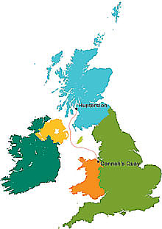
Scotland is a net exporter of electricity to England and used only some 33 TWh of the 50 TWh generated in 2011. In 2011 the installed power of Scottish wind farms was 4.8 GW and delivered 33% of this, or 13.75 TWh (Terra-Watt Hours) in the year. Their one large gas fired power station at Peterhead is a highly efficient closed cycle system unsuited to the leveling task, so all the leveling and voltage control is done from England over the main 400kV grid connector. This connector has a 1.9GW capacity which covers the current power flows. It is to be expanded to 4GW and a new High Voltage DC (HVDC) undersea line is to be installed between Flintshire and Hunterston. The investment, running costs and emissions for gas leveling in England simply do not appear in Scottish budgets or energy plans.
Without these connectors, Scottish wind power would be unusable.

Figure 3. The 1.9 GW High Voltage DC connector between Hunterston and Connah’s Key in Wales will export more power from Scotland and help level its Wind energy with English gas.

Uncertain Commitments to emissions reduction
Despite the noise about renewables, Scotland gets most of its energy from coal, gas nuclear, and a sprinkle of Hydro-electric plants. The Scottish position on coal demonstrates a very uncertain commitment to emissions reduction.
The total Scottish electricity consumption of some 50 TWh came from the Hunterston B nuclear power station (10 TWh), the old coal fired power stations on the Firth of Forth at Longannett and Cockenzie (22 TWh), and one gas fired station at Peterhead. Both coal stations are highly polluting and in breach of the EU Emissions Directive. Cockenzie (1200 MW) is to close in 2013. Longannett (2400MW) is the 3rd largest and most polluting plant in Europe. It has been retro fitted to remove sulphur and nitrogen oxide pollutants to satisfy the EU directive and its life extended to 2025. The determination to stop nuclear energy in Scotland leaves few options. A truly committed position would at least replace Longanett with a gas fired station.
It is proposed to replace the Cockenzie plant with two new coal fired stations of 400W at Grangemouth, opposite Longanett, and 1600MW beside the Hunterston B nuclear plant, increasing the amount of coal burnt in Scotland. The proposals are put forward under the guise of experimental or demonstration plants for Carbon Capture and Storage.
The Grangemouth plant is designed by Summit Power Group of Seattle. This will partially pre-burn the coal to produce Carbon Monoxide (CO) gas and capture all the sulphur and nitrogen pollutants. The Syngas will then be burned to produce electricity and the Carbon Dioxide (CO2) captured for storage and eventual burial. This is in principle the most efficient scheme for Carbon Capture and Storage (CCS), making coal potentially 90% clean of greenhouse gas emissions. The coal processing will raise the cost of the electricity by up to 30% - a price worth paying? This is not British research to position UK as a world leader in anything.
Summit almost has approval to build the first such plant in Texas. The CO2 output will be connected to 3000 miles of existing CO2 pipeline to repressurize Texas oil fields and enhance oil recovery, providing significant revenue. The plant will cost about $3Bn (£2Bn). There is no such CO2 network from Grangemouth out to North Sea oil fields. We have to question any 50 year commitment to a new coal station before the technology has been demonstrated.
The Hunterston story is more threatening. The proposal was made by the Danish state energy company, DONG, to use the less efficient post-burn capture of CO2 which has not yet been demonstrated at this scale. Denmark gets 40% of its electricity from coal and exports most of its wind energy. It would produce and capture about 5 million tones of CO2 per year. The plan is to freeze it and store it at Peterhead till a burial network is built to some oil field in the North Sea.
The critical element of any CCS scheme is the storage system. This must be secure against leaks for at least 250 years. It has not yet been demonstrated with offshore oil wells. Without an income from enhanced oil recovery the storage system is very expensive. The scale of the storage should be sufficient to hold the CO2 from all the CCS equipped coal stations in Europe for 500 years till coal itself runs out. The 2050 emissions target cannot be met if coal stations are permitted without CCS and every such plant is at risk of being shut down at any time.
A much better proposal for Hunterston would be a set of 4 X 400MW gas fired units designed as the hybrid partner to Scottish wind farms. Post-combustion CO2 capture could be added if it ever became practical as a final improvement. This would reduce the large leveling power flows between England and Scotland and simplify management of the hybrid system.

OTHER WIND FARM PROBLEMS
Various implausible schemes have been proposed to smooth the wind output or alter the load requirement to fit. DECC lists some options to show that solutions other than gas leveling may exist:
- Pumping Hydro dams as a battery system is a possibility, but the UK takes only 1.5% of its power from Hydro-electric dams. Scotland has many small Hydro-electric plants and two pumped Hydro plants which are refilled by off peak – or wind – electricity. It is not possible to expand this by a factor of ten for the whole UK.
- When the wind drops, plug-in hybrid cars can get along on petrol. Pity about the all electric ones.
- Energy intensive industries can idle their plant till the wind picks up, or move production to countries with a stable energy supply.
Wind farms occupy an enormous amount of landscape or seascape per MW installed. The whole countryside and shore lines may become an industrial landscape of satanic windmills in this most crowded country in Europe. The cumulative impact on ecosystems will be extensive and today’s flimsy researches are not fit to predict outcomes.
Interconnections could send output above 70% of peak to other EU countries, but only to those willing to take the power, and turn off their own gas, when British wind blew. Regrettably, the weather patterns stretch by up to 2000km and others will have excess wind at the same time. This might be fixed with a Supergrid extending to Turkey and North Africa but it would be absurd to build this any time soon. Only when the EU actually requests a share of UK wind energy would it make sense to extend this Hybrid system.
The Hybrid system should be responsible for balancing its own Grid input, limiting the scope of computerized control to this Hybrid grid. This would include the large converters and connections to offshore wind farms. The DECC discussion is about a single integrated grid with a One Day Ahead auction to get any of the providers to turn equipment on or off, rather like day trading on the stock market. This is as incoherent as the wind is erratic.
The costs of failure of any component of the hybrid system – windmill, connector, computer, gas station – should be borne by specific insurance with proper risk assessments. In the event that a wind farm is to be decommissioned then this should return the land or seabed back to its original condition.
It is time for the Wind industry to move away from its position of clean, free energy to a full and proper accounting of the full costs and the emissions from the reality of the Hybrid system.

ELECTRICITY PRICES IN EUROPE
There is much to consider about the price of electricity across Europe as given by Eurostats. Electricity for consumers contains a much larger tax than that applied to industry, which also benefits from buying energy in bulk. The most expensive consumer electricity is in Denmark and Germany where wind penetration is the highest. Denmark charges homeowners 40% in tax for electricity to pay for the windmills and also taxes gas for heating. The cheapest is in Poland which uses its own brown coal for most of its power. Between them, Poland and Germany burn 10 times as much coal as the UK. The cost of electricity for consumers is also inflated in Germany and Spain by heavy Feed-in-Tariffs for solar panels for homes. The owners of solar panels are actually making a profit from those who do not.
France is the next cheapest with 70% of its electricity from nuclear. Hydro-electricity should make Norway cheap but consumer energy taxes are high. Norwegian homes use up to 5 times the electricity used in English homes. The UK appears cheap due to the low tax rate on homeowners, but the Renewables Obligation Certificates (ROCs) to support renewables are a different form of tax which is not accounted for in the prices.
The cost of grid connections for industry has a low tax burden and is included in the overall prices of electricity. When separated out as industry grid costs, the large real costs of each national grid are apparent. They account for 45% of electricity cost for industry in Denmark and 26% in Germany, presumably for the large power flows and losses over long distances.
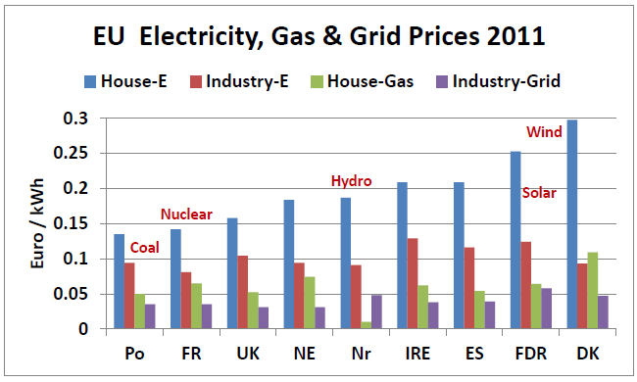

The mix of energy sources, energy policies, taxation, and complex subsidies makes it difficult to make detailed evaluations and comparisons of true energy costs. Evaluations by stock market, coming from traders and speculators, is disconnected from reality. There is little analysis to be found on the web of the actual costs of capital for new installations, the taxes paid by energy companies and equipment manufacturers, or any clarity on the risks of government interventions or windfall taxes against energy companies. The UK Draft Energy Bill 2012 will do little to make this clearer.

2050 & BEYOND
By 2050 every renewable and emissions free power source will have play a valuable part in supporting 9 billion people in at an acceptable standard of living. Conventional oil will have declined by 50-60% and will no longer be cheap. Natural Gas will also be in decline. A gigabit internet and electric vehicles will have reduced and decarbonised travel. Electric heating and combined heat and power stations will have replaced gas fired central heating.
Hydro-electricity will have been maximized within limits set by water conservation and agriculture. Hydro-electricity is dependent on weather patterns and may fail in drought conditions. Tidal energy is not synchronized with daily needs but is at least predictable and can accompany all the other sources which already follow daily load patterns. Tidal lagoons can smooth out the supply and also be pumped by excess power from erratic sources. Hydroponic biofuels may make big contributions, but burning biomass will be constrained by food production and the need to conserve major forests.
All these carbon free or carbon neutral sources will account for about 30% of world energy generation.
The erratic sources are limited by the gas leveling consumption which may account for the entire 20% of 1990 emissions which are still permissible. This means that the maximum wind plus solar power which can be used in industrialized regions is also 20% of the world total energy supply. More of these erratics may be used alone wherever that power meets similarly variable needs.
By 2050 the UK may need as little as 100GW of average generation or 876 TWh/year, or as much as 150GW. The maximum wind power for the UK is therefore 20 to 30 GW, with peaks exported or used to pump UK dams. The urgency to build half of it now is misplaced.
All other emissions free power, up to 50% of the total, must come from Nuclear and Fusion sources.
This scenario represents one of the few windows for mankind to a sustainable future on the planet. Our track record for sustaining any life form on the planet is already dire. From tigers to corals and deforestation to desertification, the uncontrolled world markets are creating extinction. Apocalyptic results are easy to see and hard to stop. The Draft Energy Bill of 2012 is just one step which could lead either way.

